TEKHACK 2021

**ANURAG GROUP OF INSTITUTIONS**

**TEAM NAME**: FANTASTIC FIVE **DOMAIN**: IOT

**PROJECT TITLE**: Water Level IOT system for overhead tanks.

**AIM**: To stop the overflow and to prevent the wastage of water using IOT system.

**DESCRIPTION**: Water level is continuously measured in a tank when the motor is ON and a level wise notification is sent to the mobile number, also motor ON and OFF are operated using the web application.

**Video link:** <https://drive.google.com/file/d/1_IA1ZimIAryqso84Pdk2PxHBkblfUwH2/view?usp=sharing>

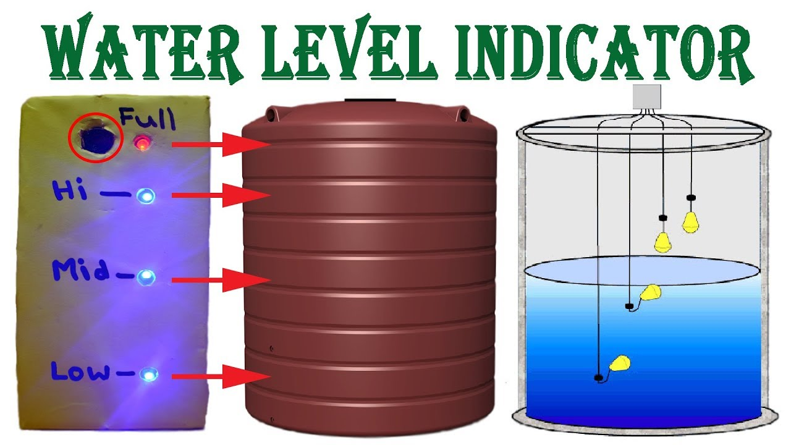

**Fig. Schematic representation**

In real time application, an **Ultrasonic sensor** is used in an overhead tank to detect the different water levels and using a simple python code, the IOT system sends a notification to the mobile number. A message is sent when then water level is almost low, enabling the user to switch ON the motor. And most importantly, When the level reaches to the maximum, the user receives a notification which enables him/her to switch OFF the motor using a web application.

Here we are demonstrating this by using the IBM cloud services, and NODE-RED software and using the python code and a messaging software, the message is being sent to the required mobile number.

The node red is accessed with a URL generated after running the command node-red in the command prompt.

The nodes in the flow1 are connected as shown:

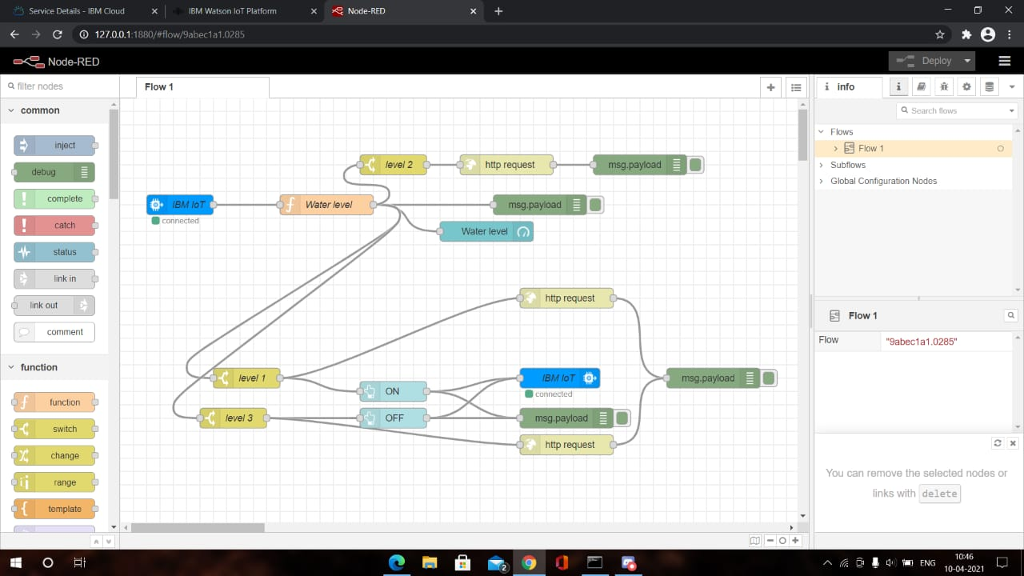

The steps followed are:

Step 1: An IBM IOT in node is used and the properties are configured:

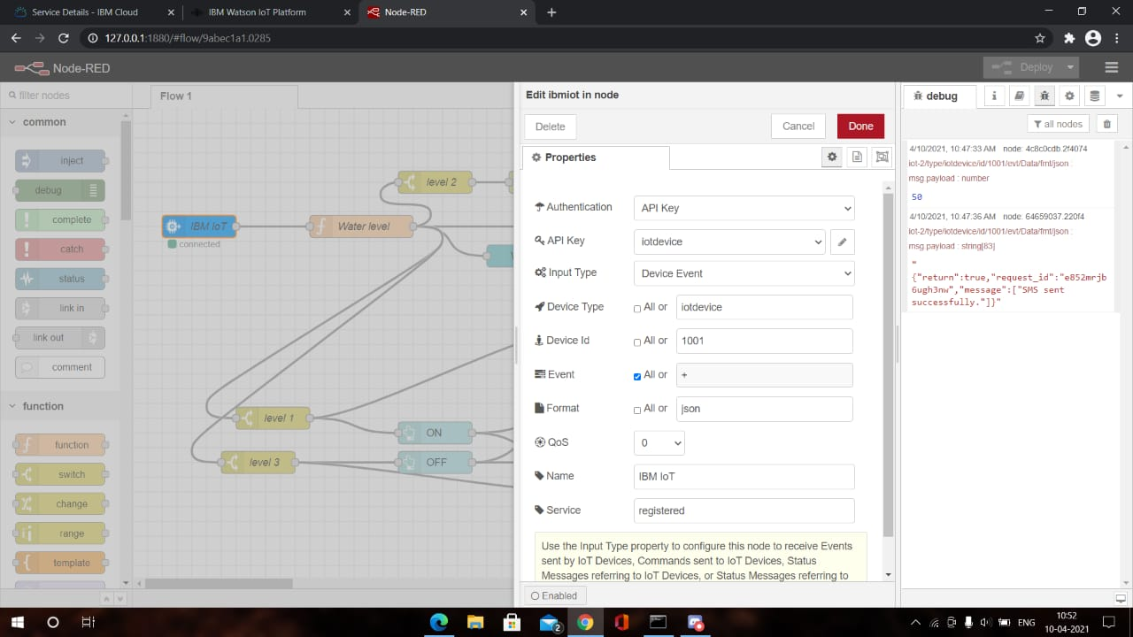

Step 2: A function node is connected to the first node and named as Water Level and function code is updated:

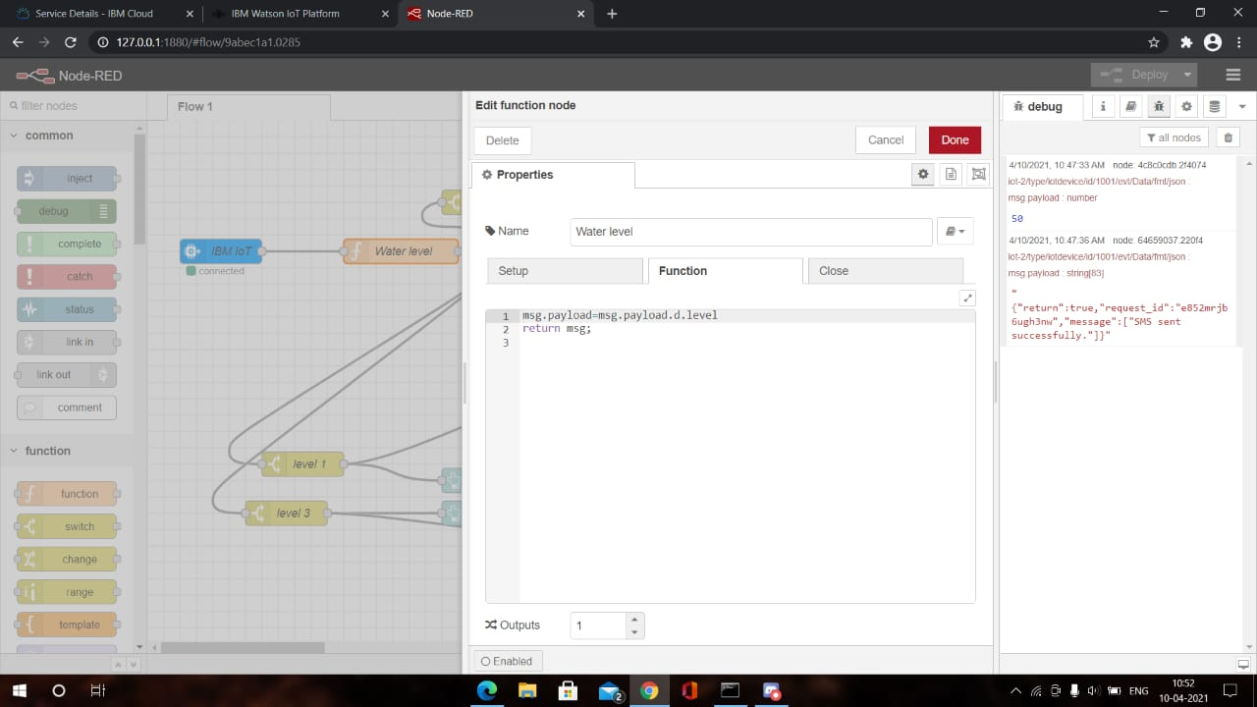

Step 3: A gauge node is connected to function node and is used to show the water level:

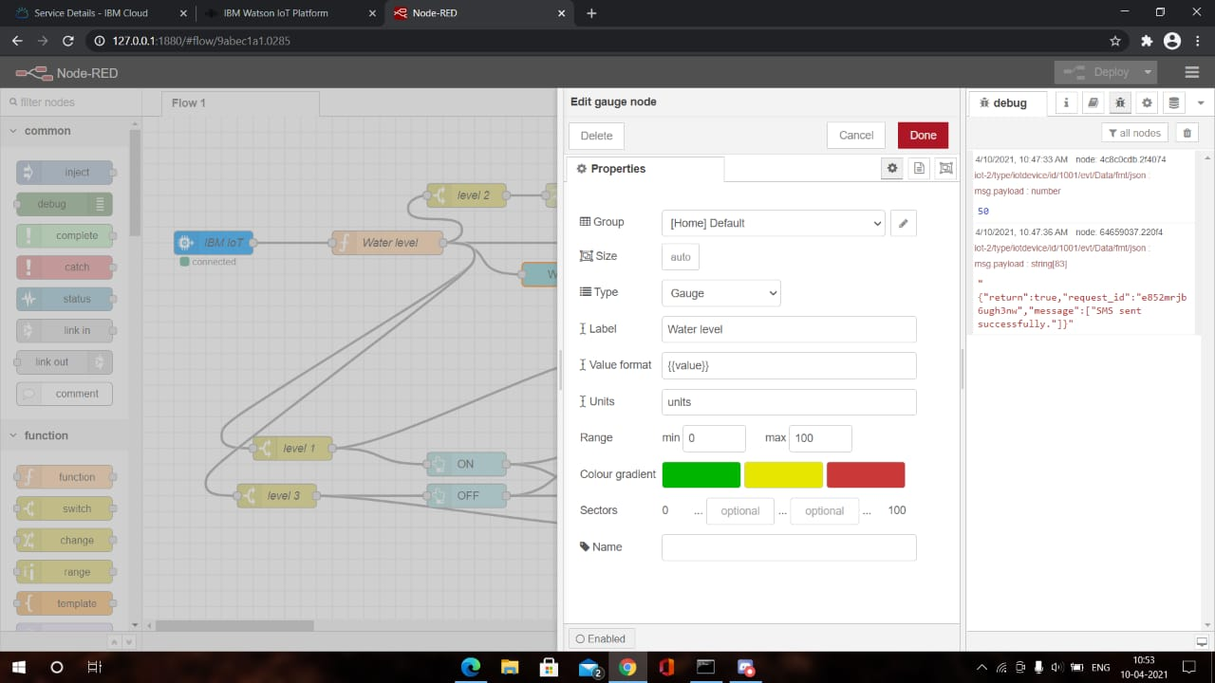

Step 4: Three switch nodes are used and are renamed as level 1, level 2 and level 3 respectively which are connected to water level node.

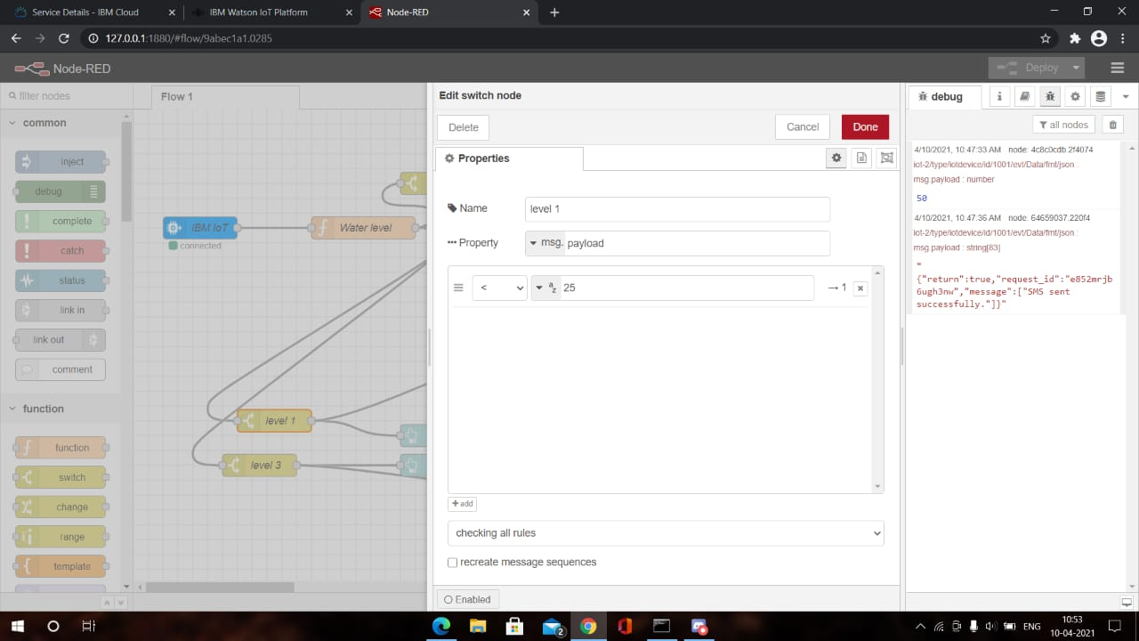

**Level 1: water level given=25**

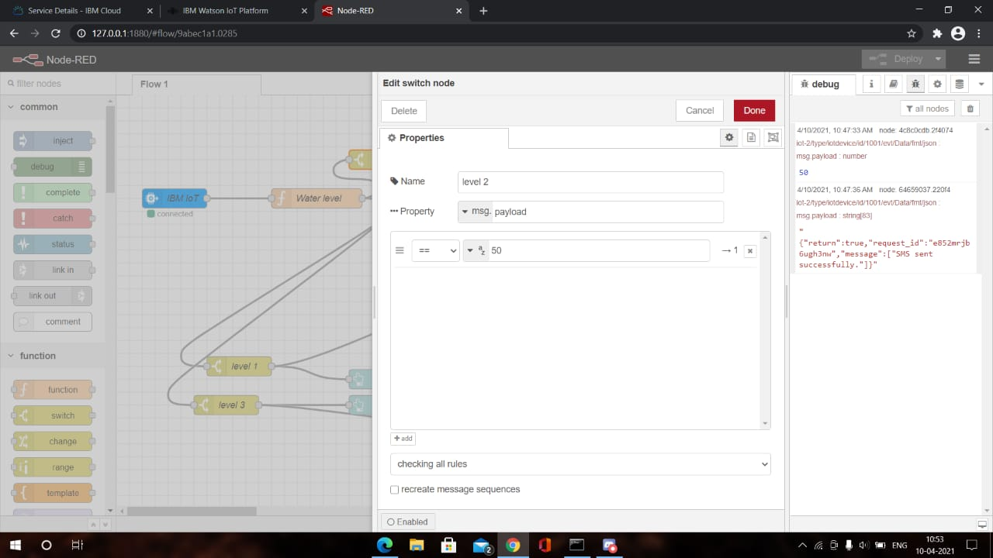

**Level 2: water level given=50**

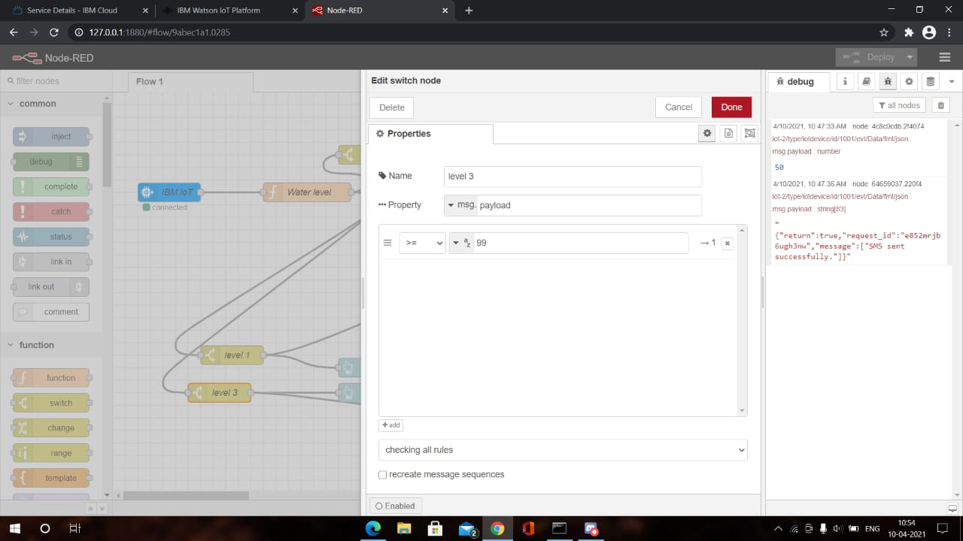

**Level 3: water level given >=99**

Step 5: Two button nodes are used and are renamed as ON and OFF buttons and are connected to level 1 and level 3 respectively.

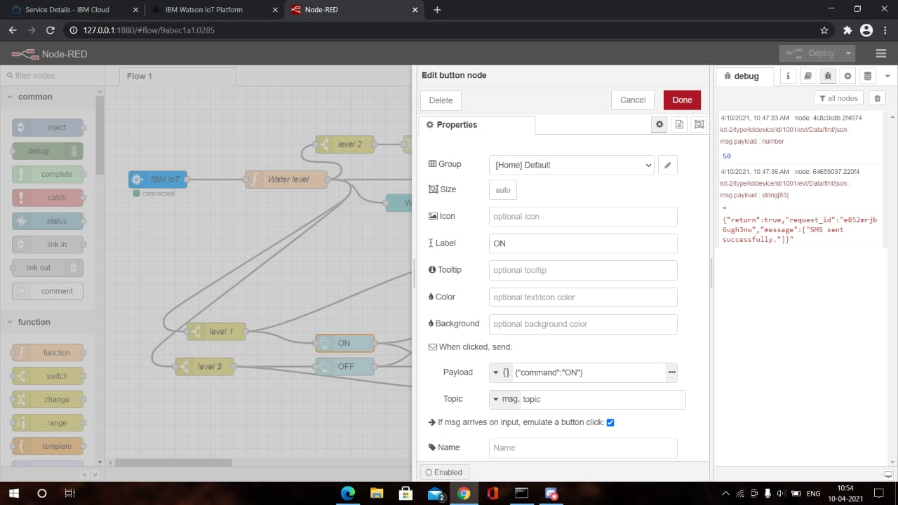

**ON command is given**

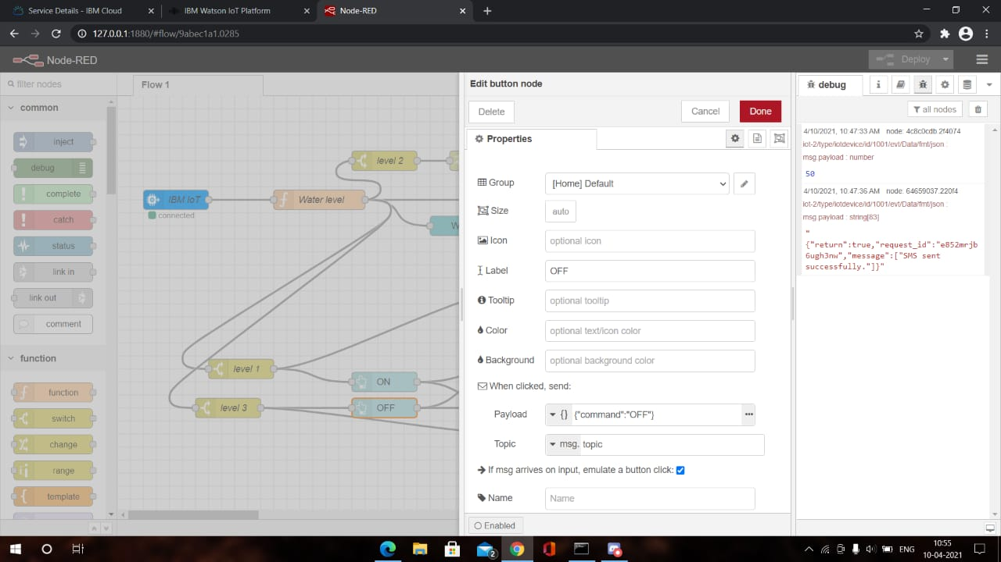

**OFF command is given**

Step 6: An IBM IOT out node is used and the properties are configured :

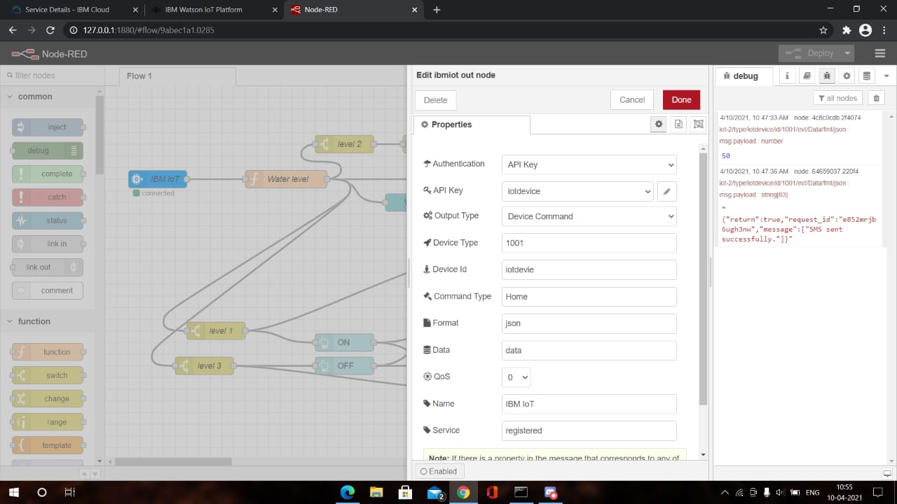

**Ibmiot out node connected to both ON and OFF buttons**

Step 7: http request nodes are connected to all the three level switches and required URL with the required message and phone numbers is given:

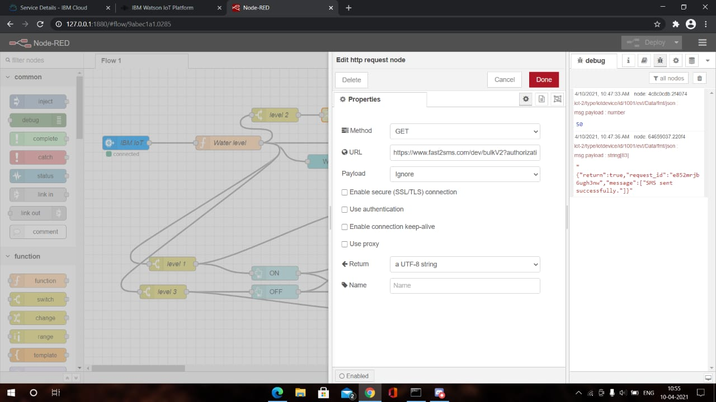

Step 8: After all the nodes are Successfully deployed , the **python** code is used to run the program and is tested with user inserted values. The message is successfully sent to the required mobile number and the water level is monitored in a web application. Here we are using the NODE-RED dashboard to check the required result.

